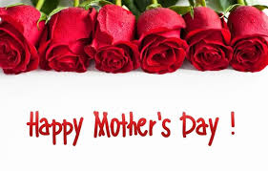

HAPPY MOTHERS DAY!

To all the mothers out there and have a safe and great weekend! This one is yours.

We hope to see everyone out on June 10'th for the Head Caretaker Bi-Election.

