CUPE Local 110

Retirement Dinner and Dance

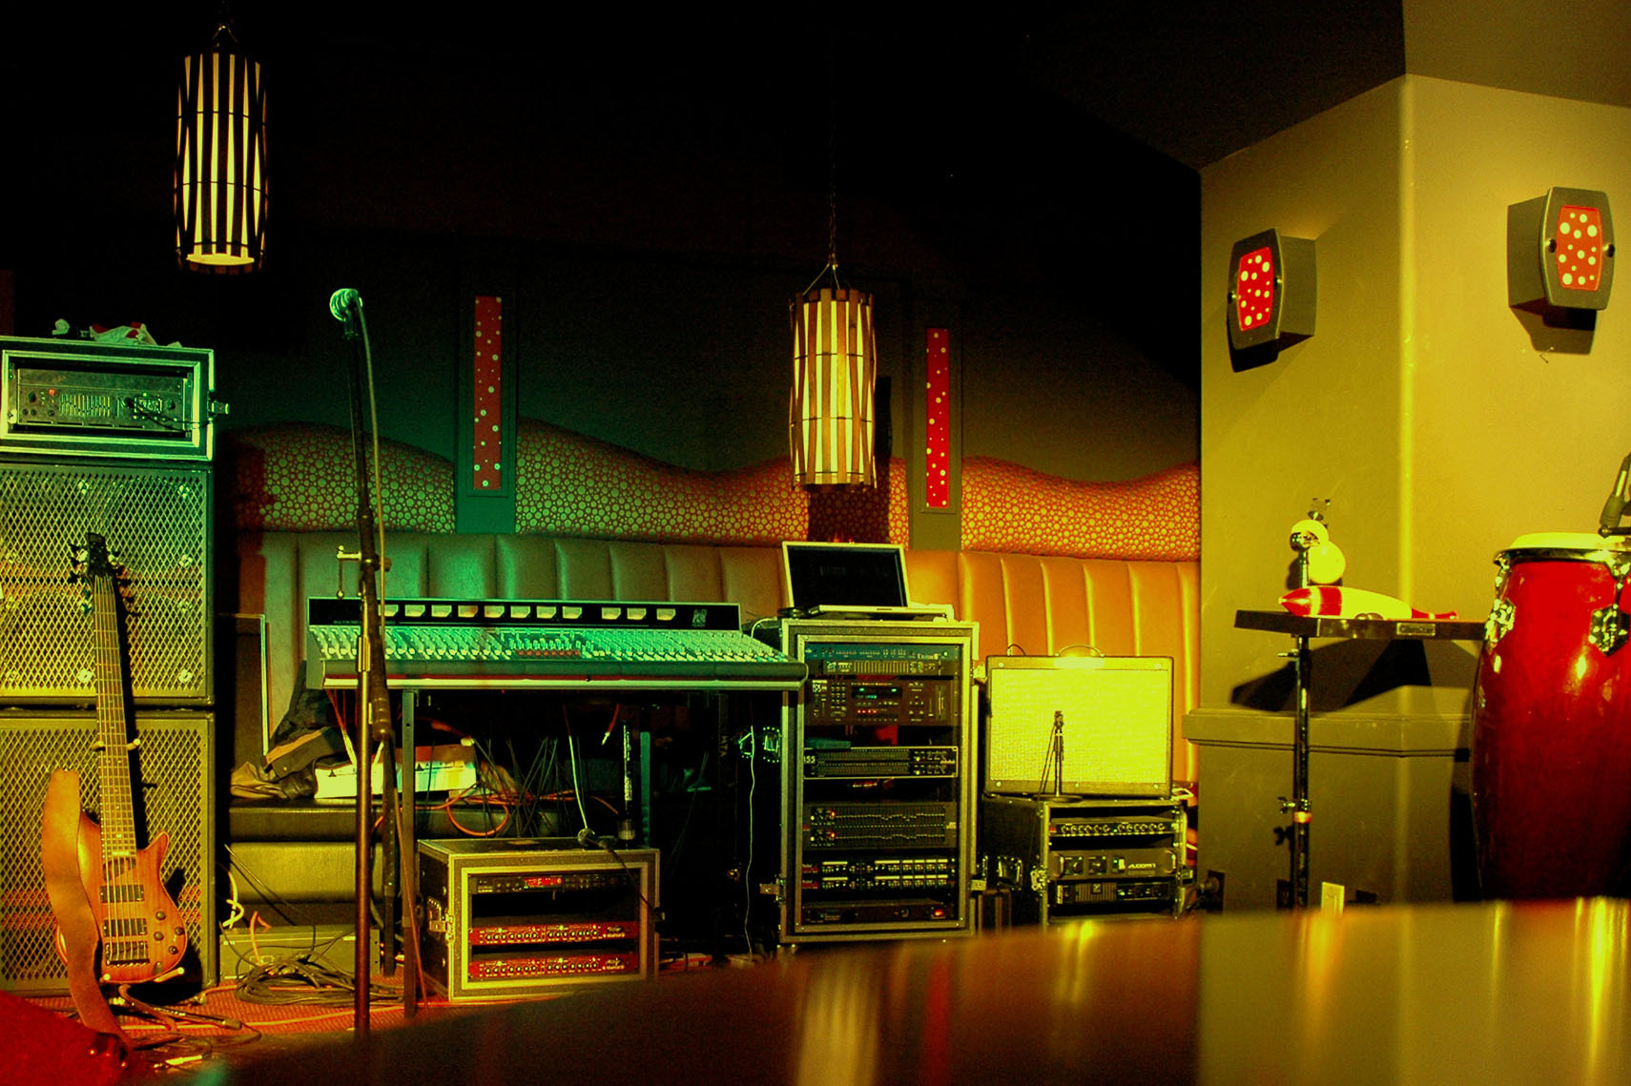
$25.00
-6:00 pm doors open.
-7:00 pm Dinner. Entrées Choice of ;
-Roast Prime Rib of Beef au jus (herbed garlic demi)
-Stuffed chicken breast with asparagus and provolone cheese.
- Dessert:
Chocolate espresso torte with hazelnut infused cream.
April/07/2018 6:00 pm – 1:00 am
Ask any local 110 executives for tickets
HOLIDAY INN, AIRPORT 1740 Ellice Avenue

